A

Capstone Project Report on

Retail Sales Analysis and Forecast System
Submitted to



Aimaxa Tech Pvt. Ltd

in partial fulfillment of

Al/ML Course
by
Pramit Shrivastav 7th 300103323037


Aimaxa Tech Pvt. Ltd
Street - 36, Smriti Nagar, Bhilai, Durg, Chhattisgarh 490020

DECLARATION BY THE STUDENT

I the undersigned solemnly declare that the report of the project work Retail Sales Analysis and Forecast System, is based on my own work carried out during the course of my study at AIMaxa PVT.LTD

I assert that the statements made and conclusions drawn are an outcome of the project work. I further declare that to the best of my knowledge and belief that the report does not contain any part of any work which has been submitted for the award of any other degree/diploma/ certificate in this University/ any other University of India or any other country.

(Signature of Student) Name of the Student(s): Pramit Shrivastav
Roll No(s).:300103323037
Enrollment No(s).:CD8634

APPROVAL CERTIFICATE

This is to Certify that the report of the project submitted is an outcome of the project work entitled Retail Sales Analysis and Forecast System carried out by Pramit Shrivastav bearing Roll No-300103323037

Under my guidance and supervision in partial fulfillment of Bachelor of Technology in Information Technology from Bhilai Institute of Technology, Durg, an autonomous institute affiliated to Chhattisgarh Swami Vivekanand Technical University, Bhilai (C.G).

To the best of my knowledge and belief the project
- Embodies the work of the candidate himself / herself,
- Has duly been completed,
- Fulfills the requirement of the Ordinance relating to the B. Tech. degree of the University,
- Is up to the desired standard for the purpose of which is submitted.

(Signature of the Supervisor)
Dr. Rajiv Pathak Associate Professor Information Technology

The Project work as mentioned above is hereby being recommended and forwarded for examination and evaluation.

Dr. (Mrs,) Ani Thomas Head of the Department Information Technology

CERTIFICATE BY THE EXAMINERS

This is to Certify that the project the entitled

“Retail Sales Analysis and Forecast System”

Submitted by

Pramit Shrivastav Enrollment No:CD8634 Roll No:300103323037

Have been examined by the undersigned as a part of the examination for the award of Bachelor of Technology degree in Information Technology from Bhilai Institute of Technology, Durg, an autonomous institute affiliated to Chhattisgarh Swami Vivekanand Technical University, Bhilai (C.G)

(Internal Examiner) (External Examiner)
Name: Name:

Date: Date:

ACKNOWLEDGEMENT

I have great pleasure in the submission of this project report entitled Retail Sales Analysis and Forecast System in partial fulfillment the degree of Bachelor of Technology. While submitting this project report, We take this opportunity to thank those directly or indirectly related to project work.

I would like to thank our supervisor Dr. Rajiv Pathak, Associate Professor who has provided the opportunity and organizing project for me. Without his active co-operation and guidance, it would have become very difficult to complete task in time.

I would like to express sincere thanks and gratitude to Dr. Anup Mishra, Principal of the Institution, Dr. (Mrs.) Ani Thomas, Head of the Department Information technology for their encouragement and cordial support.

While Submission of the capstone project, I also like to thanks to Mrs. Subhashini Spurjeon, Project Coordinator, faculties and all the staff of department of Information Technology, Bhilai Institute of Technology, Durg for their continuous help and guidance throughout the course of project.

Acknowledgement is due to our parents, family members, friends and all those persons who have helped us directly or indirectly in the successful completion of the project work.

Name of the Student(s): Pramit Shrivastav

Roll No(s):300103323037

Enrollment(s):CD8634

ABSTRACT

The rapid growth of the retail industry has resulted in the generation of massive volumes of transactional data, making effective analysis and forecasting essential for informed business decision-making. Retail organizations require intelligent systems that can transform historical sales data into meaningful insights to improve inventory management, demand forecasting, and operational efficiency. Traditional methods of sales analysis are often time-consuming and incapable of uncovering complex patterns within large datasets. This project presents a Retail Sales Analysis and Forecast using Machine Learning system that integrates data preprocessing, exploratory data analysis, interactive visualization, and predictive analytics into a unified web-based application.

The proposed system employs a comprehensive data science pipeline that includes data collection, preprocessing, feature engineering, model training, performance evaluation, and sales forecasting. Historical retail datasets containing store information, sales transactions, and external business factors are merged and processed to generate meaningful features such as day, month, year, store attributes, holiday indicators, fuel price, consumer price index, and unemployment rate. Missing values are handled using machine learning-based imputation techniques, while invalid records are cleaned to ensure data quality before model development.

The forecasting engine is developed using supervised machine learning techniques implemented in Python with the Scikit-learn library. Multiple regression algorithms, including Decision Tree Regressor, Extra Trees Regressor, Random Forest Regressor, AdaBoost Regressor, Gradient Boosting Regressor, and XGBoost Regressor, are evaluated during experimentation. The Random Forest Regressor is selected as the final forecasting model because of its superior predictive performance and robustness. Model performance is evaluated using Mean Absolute Error (MAE), Mean Squared Error (MSE), Root Mean Squared Error (RMSE), and the coefficient of determination (R² Score), ensuring reliable assessment of forecasting accuracy.

To improve usability, the system incorporates an interactive Streamlit-based dashboard that enables users to upload datasets, explore statistical summaries, visualize business trends through dynamic charts, analyze store and department performance, compare sales across different periods, and generate weekly sales forecasts through an intuitive graphical interface. The application also integrates a PostgreSQL database for efficient storage, retrieval, and management of retail sales data.

The developed system demonstrates the practical application of machine learning in retail analytics by providing accurate sales forecasting, automated business intelligence, and interactive visualization within a scalable architecture. It assists retailers in understanding sales patterns, optimizing inventory planning, and supporting strategic business decisions through data-driven insights. Furthermore, the modular design provides a strong foundation for future enhancements, including deep learning-based forecasting, real-time analytics, cloud deployment, automated model retraining, and advanced retail decision-support systems.

LIST OF TABLES

Table No. | Table Name | Page No.
4.1 | Dataset Summary | 14
5.1 | Process Dataset Feature | 24
5.2 | Evaluation Matrix | 26
5.3 | Comparison of Regression Algorithms | 28

LIST OF FIGURES

Figure  No. | Figure Name | Page No.
4.1 | System Architecture | 12
4.2 | Machine Learning Workflow | 19
4.3 | Database Architecture | 21
4.4 | Forecasting Pipeline | 22
5.1 | Data Migration | 25
5.2 | Weekly sales rankings Store wise | 25
5.3 | Weekly sales rankings Departments wise | 26
5.4 | Sales Comparison Current week versus previous week | 26
5.5 | Feature Analysis on the Basis of Size | 27
5.6 | Weekly Sales Prediction | 28

LIST OF ABBREVIATIONS

Abbreviation | Full Form
ML | Machine Learning
XGBoost | Extreme Gradient Boosting
RF | Random Forest
LR | Logistic Regression
EDA | Exploratory Data Analysis
SQL | Structured Query Language
DBMS | Database Management System
CSV | Comma-Separated Values
KPI | Key Performance Indicator
MAE | Mean Absolute Error
MSE | Mean Squared Error
RMSE | Root Mean Squared Error
R² | Root Mean Squared Error
CPI | Consumer Price Index
GUI | Graphical User Interface
ETL | Extract, Transform, Load
POS | Point of Sale
API | Application Programming Interface
REST | Representational State Transfer
PDF | Portable Document Format
BI | Business Intelligence
AI | Artificial Intelligence
DL | Deep Learning

TABLE OF CONTENTS

Section | Page No.
Abstract | i
List of Tables | ii
List of Figures | iii
List of Abbreviations | iv–v
Chapter 1: Introduction | 1
1.1 Background and Overview | 1
1.2 Motivation | 2
1.3 Organization of the Report | 3
Chapter 2: Literature Review | 4
2.1 Retail Analytics | 4
2.2 Sales Forecasting Techniques | 4
2.3 Machine Learning in Retail | 5
2.4 Existing Systems | 5
2.5 Research Gap | 6
Chapter 3: Problem Identification and Objective | 7
3.1 Problem Statement | 7
3.2 Objectives | 7
3.3 Scope of the Project | 8
3.4 Expected Outcomes | 9
Chapter 4: Methodology | 10
4.1 Experimental Setup | 10
4.2 System Architecture | 11

Section | Page No.
4.3 Dataset Description | 12
4.4 Data Cleaning and Preprocessing | 14
4.5 Feature Engineering | 16
4.6 Machine Learning Workflow | 18
4.7 Model Selection | 19
4.8 SQL Database Design | 20
4.9 Dashboard Design | 21
4.10 Forecasting Pipeline | 22
4.11 Implementation Details | 23
Chapter 5: Results and Discussion | 24
5.1 Experimental Setup | 24
5.2 Model Performance | 25
5.3 Prediction Engine Behaviour | 26
5.4 System Demonstration | 27
5.5 Comparative Analysis | 27
Chapter 6: Conclusion and Future Scope | 29
6.1 Conclusion | 29
6.2 Limitations | 29
6.3 Future Scope of Work | 30
Chapter 7: References | 31

(vi)

Chapter - 1 INTRODUCTION

Background and Overview

The retail industry has undergone a remarkable digital transformation over the past decade, generating vast amounts of transactional data through point-of-sale (POS) systems, e-commerce platforms, and customer relationship management systems. Every retail transaction records valuable information such as product details, sales amount, customer demographics, store location, purchase time, discounts, and promotional activities. When analyzed effectively, these data provide valuable insights into customer purchasing behavior, product performance, seasonal demand, and overall business profitability.

In today's highly competitive business environment, organizations increasingly rely on data-driven decision-making to improve operational efficiency and maintain market competitiveness. Retail businesses must accurately estimate future customer demand to optimize inventory levels, reduce operational costs, minimize stock shortages, and improve customer satisfaction. However, the enormous volume and complexity of retail data make manual analysis impractical and often lead to inaccurate business decisions.

Recent advances in Data Science and Machine Learning have revolutionized the way businesses analyze historical data and forecast future trends. Machine learning algorithms are capable of identifying hidden patterns, learning from historical sales records, and generating accurate predictions without requiring explicit programming rules. These predictive capabilities enable retailers to make informed decisions regarding inventory planning, marketing strategies, pricing policies, workforce allocation, and supply chain management.

Retail sales forecasting is one of the most significant applications of machine learning in business analytics. Accurate forecasting helps retailers anticipate future demand, identify seasonal fluctuations, optimize procurement strategies, and allocate resources efficiently. Alongside forecasting, interactive business intelligence dashboards and exploratory data analysis tools enable decision-makers to visualize key performance indicators, compare sales across stores and departments, and gain comprehensive insights into business performance.

The Retail Sales Analysis and Forecast using Machine Learning project has been developed to address these challenges by integrating data preprocessing, exploratory data analysis, machine learning-based forecasting, interactive visualization, and database-driven analytics into a unified web application. The system processes historical retail datasets, performs extensive preprocessing and feature engineering, trains predictive machine learning models, evaluates forecasting performance, and generates weekly sales predictions through an intuitive user interface. Furthermore, the application incorporates a PostgreSQL database for efficient data management and provides dynamic dashboards that enable users to explore sales trends, compare business performance, and generate actionable insights for strategic decision-making.

By combining modern machine learning techniques with interactive business analytics, the proposed system provides a practical solution for retail organizations seeking to transform raw transactional data into valuable business intelligence while improving forecasting accuracy and operational efficiency.

Motivation

The motivation behind this project arises from the increasing demand for intelligent retail analytics systems capable of transforming large volumes of historical sales data into meaningful business insights. Modern retail organizations continuously collect transactional information; however, much of this valuable data remains underutilized due to the absence of effective analytical tools. Traditional spreadsheet-based analysis is labor-intensive, time-consuming, and often incapable of discovering complex relationships among multiple business variables.

Another motivating factor is the growing importance of accurate sales forecasting in inventory management and supply chain optimization. Incorrect demand estimation can result in excessive inventory, increased storage costs, stock shortages, lost sales opportunities, and reduced customer satisfaction. Machine learning offers an efficient solution by learning historical sales patterns and producing reliable forecasts that assist managers in making informed business decisions.

During the development of this project, it was also observed that many existing retail forecasting applications focus solely on prediction while providing limited support for data exploration, visualization, and comparative business analysis. To overcome these limitations, the proposed system combines data preprocessing, exploratory data analysis, SQL-based data management, interactive dashboards, visualization, and machine learning forecasting within a single integrated platform. This holistic approach enables users to understand business performance comprehensively before generating future sales predictions.

Furthermore, the availability of open-source technologies such as Python, Streamlit, PostgreSQL, Pandas, Scikit-learn, Plotly, and Matplotlib makes it possible to develop an efficient, scalable, and cost-effective retail analytics platform that can be adapted to various business environments. The project therefore aims to demonstrate how machine learning can be effectively applied to solve practical business problems while providing an intuitive interface for both technical and non-technical users.

Organization of the Report

This report is organized into six chapters, each describing a specific aspect of the project development and implementation.

Chapter 1 presents the introduction to the project, including the background of retail analytics, the motivation behind the development of the proposed system, and the overall organization of the report.

Chapter 2 provides a comprehensive literature review covering existing research on retail sales forecasting, business intelligence systems, machine learning algorithms for demand prediction, exploratory data analysis techniques, and current trends in retail analytics. The chapter also identifies the research gaps addressed by the proposed system.

Chapter 3 discusses the problem statement, project objectives, scope, and expected outcomes. It explains the

business challenges associated with retail sales analysis and describes how the proposed machine learning-based solution addresses these challenges.

Chapter 4 describes the complete methodology adopted during project development. It includes the system architecture, dataset description, data preprocessing pipeline, feature engineering techniques, database design, machine learning workflow, model training, evaluation methods, forecasting process, and implementation details of the interactive dashboard.

Chapter 5 presents the experimental results and discussion. It analyzes the forecasting performance using standard regression evaluation metrics, demonstrates the functionality of the dashboard through visualizations and analytical reports, and discusses the effectiveness of the proposed system in supporting business decision-making.

Chapter 6 concludes the report by summarizing the major contributions of the project, highlighting its practical significance, discussing current limitations, and presenting potential directions for future enhancements, including advanced forecasting models, cloud deployment, real-time analytics, and intelligent retail decision support systems.

Chapter 2 LITERATURE REVIEW

Retail Analytics

Retail analytics has emerged as one of the most significant applications of data science in modern business management. With the rapid expansion of digital commerce and automated point-of-sale systems, retailers generate massive amounts of structured and unstructured data every day. This data includes customer transactions, product information, inventory records, pricing details, promotional activities, and sales performance across multiple geographical locations. The effective analysis of such data enables organizations to identify customer preferences, optimize inventory management, improve pricing strategies, and enhance overall business profitability.

Business Intelligence (BI) and retail analytics platforms convert raw transactional data into actionable insights through statistical analysis, visualization, and predictive modeling. Exploratory Data Analysis (EDA) techniques such as descriptive statistics, correlation analysis, trend analysis, and visualization help decision-makers understand sales patterns and identify factors influencing business performance. Interactive dashboards further simplify the interpretation of complex datasets by presenting key performance indicators through charts, graphs, and summary reports.

The proposed Retail Sales Analysis and Forecast using Machine Learning system incorporates these analytical techniques by providing comprehensive data preprocessing, visualization, SQL-based reporting, and business intelligence features through an interactive web application. The integration of exploratory analysis with predictive analytics allows users to obtain both historical insights and future sales forecasts within a single platform.

Sales Forecasting Techniques

Sales forecasting is a fundamental process in retail management that estimates future sales based on historical transaction records and business indicators. Accurate forecasting enables retailers to optimize inventory levels, reduce operational costs, improve supply chain efficiency, and enhance customer satisfaction. Traditionally, forecasting relied on statistical approaches such as Moving Average, Weighted Moving Average, Exponential Smoothing, Holt-Winters Method, and ARIMA (Auto-Regressive Integrated Moving Average). Although these techniques perform well on relatively stable datasets, they often struggle to capture nonlinear relationships and complex interactions among multiple variables.

Recent advancements in machine learning have significantly improved forecasting accuracy by enabling models to learn intricate patterns directly from historical data. Regression-based algorithms such as Decision Trees, Random Forests, Gradient Boosting Machines, Extra Trees, AdaBoost, and XGBoost have demonstrated strong

performance in retail forecasting because of their ability to model nonlinear relationships while handling high-dimensional datasets effectively.

In this project, several machine learning regression algorithms are experimentally evaluated during model development. After comparing their predictive performance, the Random Forest Regressor is selected as the primary forecasting model due to its robustness, resistance to overfitting, and superior accuracy in predicting weekly retail sales. The trained model is then integrated into the forecasting application to generate sales predictions for user-specified business scenarios.

Machine Learning in Retail

Machine learning has become an indispensable technology in the retail sector, enabling businesses to automate decision-making processes and extract valuable knowledge from large-scale datasets. Unlike traditional rule-based systems, machine learning algorithms continuously learn from historical data and improve prediction accuracy as additional data becomes available.

Retail organizations employ machine learning in numerous applications, including demand forecasting, inventory optimization, customer segmentation, recommendation systems, dynamic pricing, fraud detection, and supply chain optimization. Predictive models analyze historical purchasing behavior along with external factors such as seasonal trends, economic indicators, promotional campaigns, holidays, fuel prices, and consumer price indices to estimate future product demand.

The proposed system applies supervised machine learning to forecast weekly sales using historical retail transaction data. The implementation follows a complete machine learning workflow consisting of data collection, preprocessing, feature engineering, model training, evaluation, and deployment. Important business attributes such as store type, department, holiday indicators, temperature, fuel prices, consumer price index (CPI), unemployment rate, and store size are incorporated into the prediction model to improve forecasting performance. The trained model is serialized and reused during prediction, eliminating the need for repeated training and improving application efficiency.

Existing Systems

Several commercial and academic retail forecasting systems have been developed over the past decade. Enterprise platforms such as SAP Analytics Cloud, Microsoft Power BI, Tableau, and IBM Cognos provide extensive visualization and reporting capabilities. While these platforms offer powerful business intelligence features, they generally require proprietary licenses and significant technical expertise for deployment and customization.

Research-based forecasting systems typically focus on developing predictive models using individual machine learning algorithms. Many implementations emphasize only forecasting accuracy while offering limited support for exploratory data analysis, visualization, user interaction, or database management. Similarly, several academic

projects perform sales prediction using historical datasets but often require users to execute scripts manually without providing an integrated graphical interface.

The proposed Retail Sales Analysis and Forecast system addresses these limitations by combining multiple functional modules within a single application. The system integrates automated data preprocessing, SQL database management, interactive dashboards, comparative business analysis, feature visualization, and machine learning-based forecasting through a user-friendly Streamlit interface. Unlike conventional forecasting systems that emphasize only prediction, the proposed platform provides complete business analytics capabilities, enabling users to explore historical trends before generating future sales forecasts. The modular architecture also facilitates future extension with additional forecasting models and advanced analytical techniques.

Research Gap

A review of the existing literature and currently available retail analytics solutions reveals several important research gaps that motivate the development of the proposed system.

First, many forecasting applications focus exclusively on prediction accuracy while neglecting comprehensive data exploration and business intelligence capabilities. Retail managers often require historical trend analysis, comparative reporting, and interactive visualization before making strategic decisions. Integrating these functionalities within a unified platform significantly improves decision support.

Second, numerous academic forecasting models rely on standalone scripts or notebooks that require technical expertise to operate. Such implementations limit accessibility for business users who may lack programming knowledge. A web-based interactive dashboard simplifies data analysis and enables non-technical users to generate forecasts with minimal effort.

Third, existing forecasting systems frequently depend on a single source of information and provide limited support for data integration and preprocessing. Real-world retail datasets often contain missing values, duplicate records, inconsistent formats, and multiple related data sources. The proposed system addresses these challenges by implementing automated preprocessing, feature engineering, machine learning-based missing value handling, and dataset merging before model training.

Finally, relatively few academic retail forecasting projects integrate database management, exploratory data analysis, interactive visualization, comparative performance analysis, and machine learning forecasting into a single scalable application. The proposed Retail Sales Analysis and Forecast using Machine Learning system bridges this gap by providing an end-to-end retail analytics platform that supports data-driven decision-making through accurate forecasting, intuitive dashboards, and comprehensive business intelligence features.

Chapter - 3

PROBLEM IDENTIFICATION AND OBJECTIVE

  - Problem Statement The rapid growth of the retail industry has resulted in an enormous increase in the volume of transactional data generated through point-of-sale (POS) systems, online shopping platforms, and customer management systems. Although this data contains valuable business information, many retail organizations are unable to fully utilize it due to the lack of intelligent analytical tools capable of extracting meaningful insights. Traditional methods of analyzing sales data, which primarily rely on spreadsheets and manual reporting, are time-consuming, error-prone, and incapable of identifying complex patterns present within large datasets.

One of the most significant challenges faced by retailers is forecasting future sales accurately. Sales are influenced by numerous factors, including seasonal variations, holidays, promotional campaigns, economic conditions, store characteristics, and customer purchasing behavior. Conventional forecasting techniques often fail to capture these nonlinear relationships, resulting in inaccurate demand estimation. Poor forecasting can lead to excessive inventory, stock shortages, increased operational costs, inefficient supply chain management, and reduced customer satisfaction.

Another challenge is the quality of retail datasets. Real-world sales data frequently contains missing values, duplicate records, inconsistent formats, and incomplete information collected from multiple sources. These issues negatively affect forecasting accuracy if appropriate preprocessing and feature engineering techniques are not applied before model training.

Furthermore, many existing retail forecasting applications focus exclusively on prediction while providing limited capabilities for exploratory data analysis, visualization, comparative reporting, and interactive business intelligence. Business managers require a comprehensive platform that not only predicts future sales but also helps them understand historical trends, compare store and departmental performance, identify key business drivers, and visualize important performance indicators through an intuitive graphical interface.

To address these challenges, the proposed Retail Sales Analysis and Forecast using Machine Learning system integrates data preprocessing, exploratory data analysis, machine learning-based forecasting, SQL-based data management, and interactive visualization within a unified web application. The system enables retailers to analyze historical sales data, generate meaningful business insights, forecast future weekly sales, and support informed decision-making through an efficient and user-friendly analytical platform.

Objectives

The primary objective of the proposed project is to develop an intelligent retail analytics and sales forecasting system that combines machine learning techniques with interactive business intelligence tools to support data-driven decision-making.

The specific objectives of the project are as follows:

    - To develop an interactive web-based retail analytics system capable of processing historical retail transaction datasets.

    - To implement an automated data preprocessing pipeline that performs dataset merging, missing value handling, duplicate removal, feature transformation, and data cleaning prior to model training.

    - To perform comprehensive Exploratory Data Analysis (EDA) for understanding sales patterns, customer behavior, product performance, and regional sales trends through statistical analysis and visualization.

    - To engineer meaningful predictive features such as day, month, year, holiday indicators, store characteristics, fuel prices, consumer price index, and unemployment rate for improving forecasting accuracy.

    - To train and evaluate multiple machine learning regression algorithms and identify the most suitable model for retail sales forecasting.

    - To develop a machine learning-based forecasting engine capable of accurately predicting future weekly retail sales using historical transaction data.

    - To evaluate forecasting performance using standard regression metrics including Mean Absolute Error (MAE), Mean Squared Error (MSE), Root Mean Squared Error (RMSE), and R² Score.

    - To integrate PostgreSQL database management for efficient storage, retrieval, and analysis of retail sales information.

    - To provide interactive dashboards and business reports using modern visualization libraries for effective interpretation of retail performance.

    - To develop a scalable and modular system architecture that can be extended with advanced forecasting algorithms and additional business intelligence features in future versions.

Scope of the Project

The proposed Retail Sales Analysis and Forecast using Machine Learning system is designed to function as an intelligent business analytics and forecasting platform for retail organizations. The system accepts historical retail sales datasets containing store information, departmental sales records, promotional data, economic indicators, and environmental variables for analysis and prediction.

The scope of the project includes data preprocessing, exploratory data analysis, feature engineering, machine learning model training, forecasting, database integration, and visualization. Users can upload or utilize existing retail datasets, explore statistical summaries, compare store and department performance, visualize sales trends, and generate future weekly sales forecasts using the trained machine learning model.

The application provides multiple analytical modules including sales comparison, top-performing store analysis, feature analysis, SQL-based reporting, and interactive dashboards. These capabilities enable users to gain a comprehensive understanding of historical business performance before generating future predictions.

The forecasting component focuses on supervised machine learning regression techniques and predicts weekly sales based on historical business data and related influencing factors. The trained model is stored and reused during inference, reducing computational overhead while improving application responsiveness.

The project is intended primarily as a business decision support tool and educational demonstration of machine learning applications in retail analytics. It does not incorporate real-time streaming data, online learning algorithms, or cloud-based distributed processing. Additionally, the current implementation forecasts weekly sales and does not directly address long-term strategic planning, inventory optimization algorithms, or recommendation systems, although the modular architecture supports such future enhancements.

Expected Outcomes

The successful implementation of the proposed system is expected to achieve the following outcomes:

- Development of a fully functional web-based retail analytics and forecasting application.

- Automated preprocessing and cleaning of retail transaction datasets for improved data quality.

- Generation of comprehensive exploratory data analysis reports and business insights through interactive visualizations.

- Accurate prediction of future weekly retail sales using machine learning regression techniques.

- Evaluation of forecasting performance using standard regression metrics to ensure prediction reliability.

- Interactive dashboards enabling users to analyze sales performance, compare stores and departments, and visualize important business indicators.

- Efficient storage and management of retail data through PostgreSQL database integration.

- Reduction in manual analytical effort through automation of data processing and forecasting tasks.

- Improved support for business decision-making in areas such as inventory planning, demand forecasting, sales monitoring, and resource allocation.

- Establishment of a scalable and modular retail analytics platform that can serve as a foundation for future research involving deep learning, time-series forecasting, cloud deployment, automated retraining, customer segmentation, and advanced business intelligence systems.

8

Chapter - 4 METHODOLOGY

Experimental Setup

The proposed Retail Sales Analysis and Forecast using Machine Learning system was developed and evaluated using a standard personal computer equipped with Python as the primary programming language. The project was implemented using an integrated environment consisting of data preprocessing libraries, machine learning frameworks, visualization tools, database connectivity, and a web-based dashboard. The development environment was configured using Visual Studio Code with a Python virtual environment to ensure dependency management and reproducibility.

The machine learning models were developed using the Scikit-learn library, while additional regression algorithms such as XGBoost were used for comparative evaluation during experimentation. Data manipulation and preprocessing operations were performed using Pandas and NumPy, whereas Matplotlib, Seaborn, and Plotly were employed for generating statistical visualizations and interactive business charts. The application interface was developed using Streamlit, providing an interactive dashboard through which users can upload datasets, perform analyses, and generate sales forecasts. The backend also integrates PostgreSQL using the psycopg2 library for storing and retrieving retail sales information efficiently.

The forecasting model was trained using historical retail sales datasets after applying preprocessing and feature engineering techniques. Multiple regression algorithms were evaluated on the same processed dataset, and their performances were compared using standard regression evaluation metrics including Mean Absolute Error (MAE), Mean Squared Error (MSE), Root Mean Squared Error (RMSE), and the coefficient of determination (R² Score). The Random Forest Regressor demonstrated superior predictive performance and was therefore selected as the final forecasting model. The trained model was serialized using Python’s Pickle module and reused during prediction, eliminating the need for repeated training during application execution.

System Architecture

The proposed system follows a modular architecture that separates data acquisition, preprocessing, storage, machine learning, visualization, and forecasting into independent components. This modular design improves maintainability, scalability, and ease of future enhancements.

The system architecture consists of six primary layers:

- Data Layer

- Preprocessing Layer

- Database Layer

- Machine Learning Layer

- Visualization Layer

- Prediction Layer

Initially, historical retail datasets containing store information, sales records, and external business factors are loaded into the system. The preprocessing module cleans the datasets, removes inconsistencies, handles missing values, converts data types, and generates additional predictive features. The processed data is then stored in a PostgreSQL database, enabling efficient querying and analytical operations.

The machine learning layer extracts relevant features from the processed dataset and trains regression models to learn historical sales patterns. After evaluation, the trained Random Forest model is stored as a serialized file and loaded during inference. The visualization layer presents business insights through interactive charts and dashboards, while the prediction layer accepts user input and generates weekly sales forecasts using the trained model.

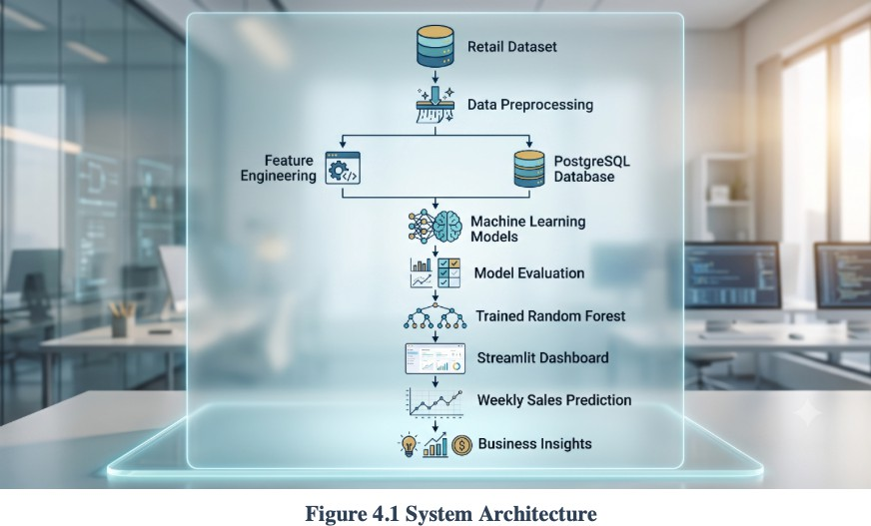

Dataset Description

The proposed forecasting system utilizes historical retail transaction datasets consisting of three primary data sources:

- Sales Dataset

- Store Dataset

- Features Dataset

These datasets are merged using the common Store attribute to create a unified dataset suitable for machine learning and business analytics.

Sales Dataset

The Sales Dataset contains weekly sales transactions recorded across multiple stores and departments. Important attributes include:

- Store ID

- Department ID

- Weekly Sales

- Date

- Holiday Indicator

Store Dataset

The Store Dataset provides information regarding each retail outlet. Important attributes include:
- Store Number

- Store Type

- Store Size

Features Dataset

The Features Dataset contains external variables that influence sales performance. These include:
- Temperature

- Fuel Price

- Consumer Price Index(CPI)

- Unemployment Rate

- MarkDown1

- MarkDown2

- MarkDown3

- MarkDown4

- MarkDown5

- Holiday Indicator

The three datasets are merged during preprocessing to generate a comprehensive dataset covering retail operations between multiple years. Dataset merging is performed using Pandas merge operations based on store identifiers and transaction dates before further preprocessing and model training.

Table 4.1 Dataset Summary

Dataset | Dataset | Dataset
Sales | Weekly Sales Transaction | Description
  Major Attributes | Major Attributes | Major Attributes
Sales | Sales | Sales

Data Cleaning and Preprocessing

Data preprocessing is one of the most critical phases of the proposed system, as forecasting accuracy largely depends on the quality of the input data. The preprocessing pipeline transforms raw retail datasets into structured information suitable for machine learning.

The preprocessing process consists of the following stages:

    - Dataset Merging

Initially, the sales, store, and feature datasets are merged using the Store attribute and transaction dates. Duplicate columns created during merging are removed, and the resulting dataset is reorganized into a consistent format.

    - Data Type Conversion

Date attributes are converted into Python datetime objects to facilitate feature extraction. Categorical variables such as Store Type and Holiday Indicator are encoded into numerical values suitable for regression algorithms.

    - Missing Value Handling

Several variables, particularly the promotional MarkDown features, contain missing values. Instead of simply discarding incomplete records, the project applies machine learning–based imputation techniques to estimate missing values where appropriate. Missing values in CPI and

Unemployment are also predicted using regression models before final forecasting.

    - Invalid Data Removal

Negative weekly sales values are treated as invalid observations and replaced with missing values before subsequent processing. This improves the reliability of model training and prevents unrealistic predictions.

    - Date Feature Extraction

The Date column is decomposed into several temporal features:

      - Day

      - Month

      - Year

These features capture seasonal purchasing behavior and improve forecasting performance.

    - Data Organization

After preprocessing, the dataset contains numerical attributes suitable for regression modeling, including:

      - Day

      - Month

      - Year

      - Store

      - DepartmentStore

      - Type

      - Store

      - Size

      - Holiday Indicator

      - Temperature

      - Fuel Price

      - CPI

      - Unemployment

      - Weekly Sales

      - The preprocessing pipeline ensures that the forecasting model receives consistent, high-quality input data while minimizing information loss caused by missing or inconsistent records.

Feature Engineering
Feature engineering is a crucial stage in the machine learning pipeline, as the predictive capability of the forecasting model largely depends on the quality and relevance of the input features. In the proposed system, several meaningful features are extracted and transformed from the original retail datasets to improve forecasting performance and model generalization.

The feature engineering process includes temporal feature extraction, categorical feature encoding, feature selection, and construction of additional business variables that better represent retail sales behavior.

Temporal Feature Extraction

The original dataset contains a transaction Date column that records the weekly sales period. Since machine learning algorithms cannot directly interpret date values, the Date attribute is decomposed into multiple numerical components including:

- Day

- Month

- Year

These temporal features enable the forecasting model to capture seasonal trends, yearly growth, and monthly purchasing behavior that significantly influence retail sales.

Categorical Feature Encoding

Several dataset attributes are categorical in nature and therefore require numerical encoding before model training.

The encoding process includes:

- Store Type (A, B, C) → Numeric values

- Holiday Indicator (True/False) → Binary values (1/0)

This transformation enables regression algorithms to process categorical business information without introducing computational complexity.

Business Feature Selection

After preprocessing, the following features are selected for forecasting:

- Day

- Month

- Year

- Store

- Department

- Store Type

- Store Size

- Holiday Indicator

- Temperature

- Fuel Price

- Consumer Price Index (CPI)

- Unemployment Rate

These attributes collectively represent internal business factors as well as external economic conditions affecting weekly sales. The selected features are passed to the regression model during both training and prediction.

Handling Promotional Variables

The retail dataset contains five promotional attributes (MarkDown1–MarkDown5). These variables contain a significant number of missing values. During experimentation, two forecasting approaches were investigated:

- Forecasting with MarkDown variables after machine learning-based imputation.

- Forecasting without MarkDown variables.

Experimental evaluation indicated that the simplified model without promotional variables produced more stable predictions while reducing preprocessing complexity. Consequently, the final implementation employs the second approach, retaining only the most informative business variables for forecasting.

Machine Learning Workflow

The proposed forecasting system follows a structured machine learning workflow that converts raw retail data into accurate weekly sales predictions. Each stage of the workflow contributes to improving forecasting accuracy and ensuring reliable business intelligence.

The workflow consists of the following sequential stages:

- Data Collection

- Data Cleaning

- Dataset Integration

- Feature Engineering

- Train-Test Split

- Model Training

- Model Evaluation

- Model Serialization

- Sales Prediction

- Dashboard Visualization

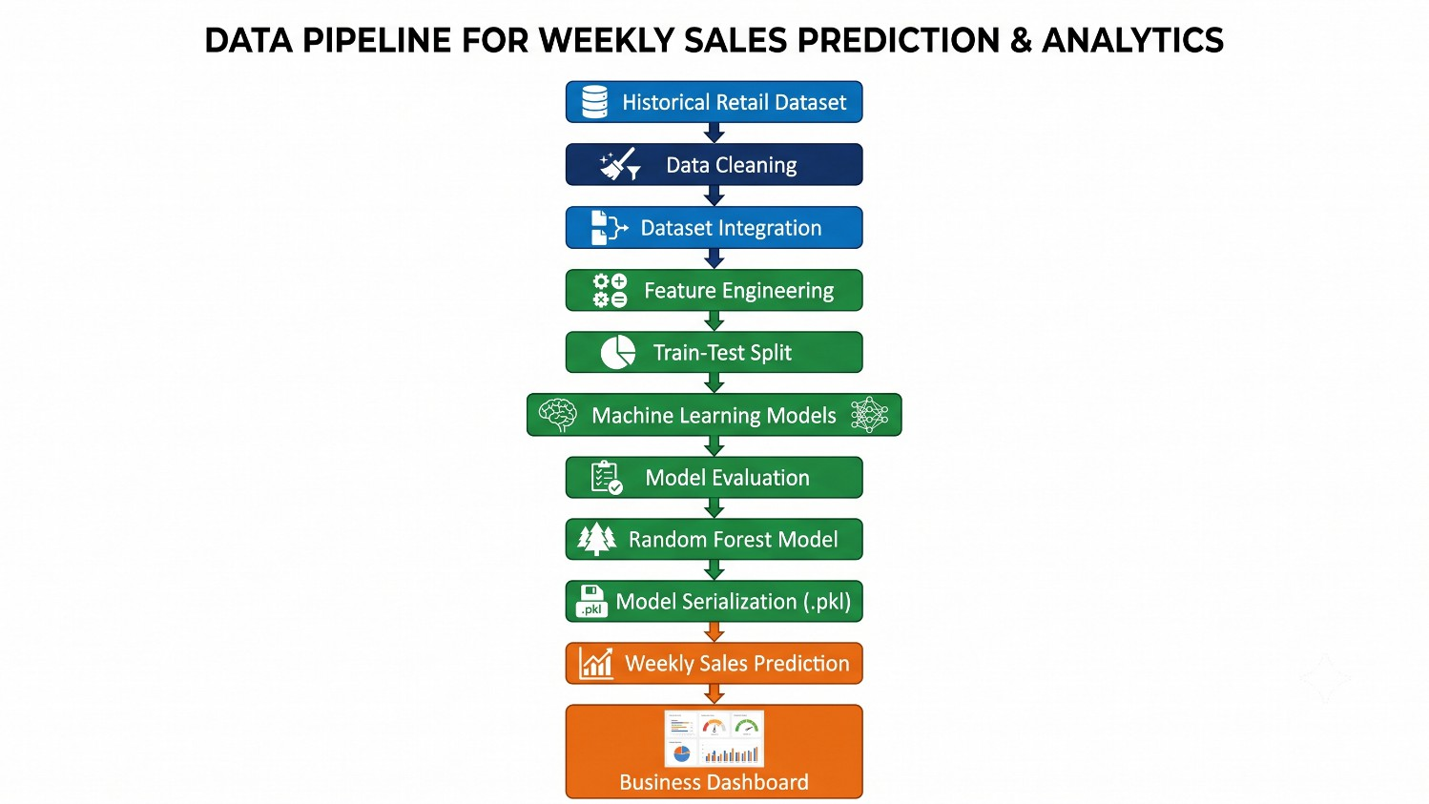

Figure 4.2 Machine Learning Workflow

The workflow begins with preprocessing the historical datasets, followed by extraction of relevant predictive features. The processed data is divided into training and testing subsets using the Scikit-learn train-test split procedure. Multiple regression algorithms are then trained and evaluated. After selecting the best-performing model, it is serialized using the Pickle library and integrated into the Streamlit dashboard for real-time prediction.

Model Selection

Selecting an appropriate forecasting algorithm is one of the most important stages in predictive analytics. Since retail sales exhibit nonlinear relationships with various business and environmental factors, ensemble machine learning algorithms generally provide better predictive performance than simple linear models.

Several regression algorithms were evaluated during experimentation, including:

- Decision Tree Regressor

- Extra Trees Regressor

- Random Forest Regressor

- AdaBoost Regressor

- Gradient Boosting Regressor

- XGBoost Regressor

Each algorithm was trained using the same processed dataset and evaluated using identical train-test partitions to ensure fair comparison. Performance was measured using standard regression metrics including Mean Absolute Error (MAE), Mean Squared Error (MSE), Root Mean Squared Error (RMSE), and the coefficient of determination (R² Score).

Among the evaluated models, the Random Forest Regressor consistently produced the most reliable forecasting performance. Random Forest combines predictions from multiple decision trees, reducing variance and improving generalization while minimizing the risk of overfitting. It also performs well on high-dimensional retail datasets and effectively models nonlinear interactions among business variables.

After training, the selected Random Forest model is serialized into a Pickle file (model2.pkl) and reused during inference. This significantly reduces prediction time because the application loads the pre-trained model directly rather than retraining it each time a forecast is requested.

SQL Database Design

To improve data management and analytical capabilities, the proposed system integrates a PostgreSQL relational database. The database stores retail sales records after preprocessing and serves as the foundation for various analytical modules implemented in the dashboard.

The primary database table is Sales, which contains attributes including:

- Day

- Month

- Year

- Store

- Department

- Store Type

- Weekly Sales

- Store Size

- Holiday Indicator

- Temperature

- Fuel Price

- MarkDown1–MarkDown5

- CPI

- Unemployment

The application automatically performs:

- Database creation

- Table creation

- Data migration

- SQL querying

- Analytical reporting

Database operations are implemented using the psycopg2 Python library, which provides secure communication between the Streamlit application and PostgreSQL server. SQL queries support modules such as Top Stores, Department Analysis, Store Comparison, Feature Analysis, and Weekly Sales Reporting.
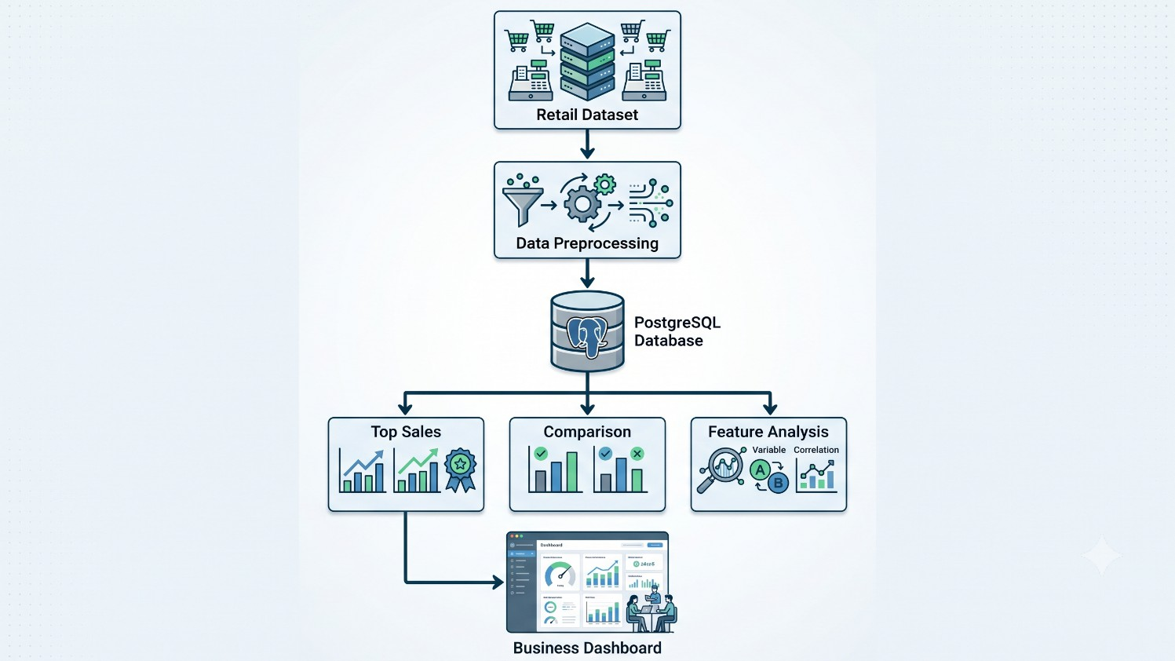

Figure 4.3 Database Architecture

Dashboard Design

The user interface of the proposed system is implemented using the Streamlit framework, enabling users to perform retail analytics without requiring programming knowledge. The dashboard follows a modular design in which each analytical task is organized as an independent module accessible through a navigation sidebar.

The dashboard includes the following modules:

- Data Migration

- Top Sales Analysis

- Store Comparison

- Feature Analysis

- Weekly Sales Prediction

Interactive widgets such as date selectors, dropdown menus, numeric input fields, and buttons allow users to filter data dynamically. Business insights are presented using interactive charts developed with Plotly, while statistical summaries and comparison metrics are displayed through customized dashboard components.

The interface provides real-time visualization of business performance, enabling users to compare store performance, evaluate departmental sales, analyze feature impacts, and generate weekly sales forecasts through an intuitive graphical environment.

Forecasting Pipeline

The forecasting pipeline represents the final stage of the proposed system, where the trained machine learning model generates weekly sales predictions based on user input.

The forecasting process consists of the following steps:

- Load the pre-trained Random Forest model.

- Receive user inputs through the Streamlit dashboard.

- Automatically determine Store Type and Store Size based on Store ID.

- Convert categorical variables into numerical representations.

- Construct the feature vector in the required order.

- Pass the feature vector to the trained model.

- Predict weekly sales.

- Display the forecast within the dashboard.

The prediction module allows users to specify information such as store number, department, holiday status, temperature, fuel price, CPI, unemployment rate, and transaction date. These values are converted into the feature format expected by the trained regression model before prediction.

The generated sales forecast is displayed instantly, providing retailers with estimated weekly revenue that can be used for inventory planning, staffing decisions, and business strategy.
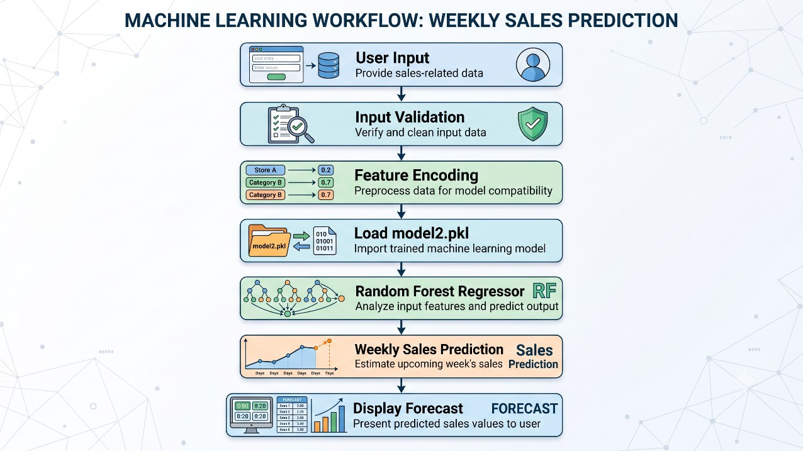

Figure 4.4 Forecasting Pipeline

Implementation Details

The proposed Retail Sales Analysis and Forecast system is implemented using a modular software architecture that separates different functional responsibilities into independent components, thereby improving code maintainability and scalability.

The implementation consists of several Python modules responsible for data preprocessing, database management, visualization, comparative analysis, feature analysis, and forecasting. The preprocessing module merges the retail datasets, cleans missing values, performs feature engineering, and prepares the data for machine learning. The database module manages PostgreSQL operations, including table creation, data migration, and SQL queries required for analytical reporting. The visualization module generates interactive charts and dashboards using Plotly, Matplotlib, and Seaborn, while the forecasting module loads the serialized Random Forest model and performs real-time prediction based on user inputs.

The complete application is developed in Python and integrates several open-source libraries, including Pandas for data manipulation, NumPy for numerical computation, Scikit-learn for machine learning, Plotly for interactive visualization, Matplotlib and Seaborn for statistical graphics, PostgreSQL with psycopg2 for database connectivity, and Streamlit for developing the web interface. This modular implementation allows the system to be easily extended with additional forecasting algorithms, advanced analytical modules, cloud deployment capabilities, and real-time business intelligence features in future versions.

Chapter - 5 RESULT AND DISCUSSION

Dataset Analysis

    - The effectiveness of any machine learning model depends largely on the quality of the dataset used for training and evaluation. Therefore, a comprehensive analysis of the retail dataset was performed before model development. The proposed system combines three independent datasets containing store information, weekly sales records, and external business factors into a unified dataset suitable for forecasting.

    - During preprocessing, the datasets were examined for missing values, duplicate records, inconsistent data types, and invalid observations. The analysis revealed that the promotional variables (MarkDown1–MarkDown5) contained a significant number of missing values, while a small number of missing values were also observed in the Consumer Price Index (CPI) and Unemployment attributes. Rather than discarding these records, the system employed machine learning-based imputation techniques to estimate missing values, thereby preserving valuable information for model training. In addition, negative weekly sales values were identified as invalid and treated as missing observations before further processing.

    - The transaction date attribute was transformed into separate Day, Month, and Year components, allowing the forecasting model to capture temporal trends and seasonal purchasing patterns. Categorical variables such as Store Type and Holiday Indicator were encoded into numerical representations to facilitate machine learning.

    - After preprocessing, the final dataset contained cleaned numerical attributes describing store characteristics, sales information, promotional indicators, and external economic variables. These features formed the basis for exploratory data analysis and machine learning model development.

Table 5.1 Processed Dataset Features

Feature Category | Attributes
Temporal Features | Day, Month, Year
Store Information | Store ID, Department ID, Store Type, Store Size
Business Features | Weekly Sales, Holiday Indicator
Economic Indicators | Fuel Price, Consumer Price Index (CPI), Unemployment Rate

Feature Category | Attributes
Environmental Factors | Temperature
Promotional Variables | MarkDown1, MarkDown2, MarkDown3, MarkDown4, MarkDown5 (used during experimentation and feature engineering)

Visualizations

    - Data visualization plays a vital role in understanding retail business performance and identifying patterns that may not be immediately apparent from raw data. The proposed system incorporates multiple interactive visualization modules developed using Plotly, Matplotlib, and Seaborn, allowing users to explore sales performance dynamically.

    - The dashboard provides several graphical representations of retail data, including:

    - Weekly sales trends

    - Top-performing stores

    - Department-wise sales

    - Feature distribution

    - Correlation heatmap

    - Sales comparison charts

    - Store performance analysis

    - Feature impact visualization

    - These visualizations assist business managers in identifying high-performing stores, understanding the influence of external variables, monitoring seasonal demand, and comparing sales across different departments and locations.

    - The correlation heatmap generated during preprocessing illustrates relationships among numerical variables. Strong positive or negative correlations help identify the most influential factors affecting weekly sales and support feature selection during model development. Similarly, interactive bar charts and comparison graphs enable users to compare weekly sales among multiple stores and departments using SQL-based queries executed through the dashboard.

Model Performance

Several supervised machine learning regression algorithms were evaluated to determine the most suitable model for forecasting weekly retail sales. The experimentation phase included Decision Tree Regressor, Extra Trees Regressor, Random Forest Regressor, AdaBoost Regressor, Gradient Boosting Regressor, and XGBoost Regressor.

Each model was trained using identical datasets and evaluated using standard regression metrics. The performance evaluation was based on:

    - Mean Absolute Error (MAE)

    - Mean Squared Error (MSE)

    - Root Mean Squared Error (RMSE)

    - Coefficient of Determination (R² Score)

The experimental results demonstrated that the Random Forest Regressor consistently produced the highest prediction accuracy and the lowest prediction error among the evaluated algorithms. Due to its ensemble learning approach, Random Forest effectively captures nonlinear relationships between multiple retail variables while reducing overfitting and improving model generalization.

Following model evaluation, the trained Random Forest model was serialized into a Pickle file (model2.pkl) and integrated into the Streamlit application for real-time forecasting. This approach significantly reduces computation time by avoiding repeated model training during prediction.

Table 5.2 Evaluation Metrics

Evaluation Metric | Purpose
Mean Absolute Error (MAE) | Measures the average absolute difference between actual and predicted sales values.
Mean Squared Error (MSE) | Measures the average squared prediction error, giving greater penalty to larger errors.
Root Mean Squared Error (RMSE) | Represents the prediction error in the same unit as the target variable, making interpretation easier.
Coefficient of Determination (R² Score) | Measures how well the regression model explains the variability in actual sales data.

The overall experimental results indicate that the selected forecasting model provides reliable predictions suitable for retail business decision support.

Forecast Results

The forecasting module enables users to estimate future weekly sales by entering relevant business parameters through the web interface. User inputs include transaction date, store number, department, holiday status, temperature, fuel price, CPI, and unemployment rate. The application automatically retrieves additional store information such as store type and size before constructing the final feature vector used by the prediction model.

Upon receiving user inputs, the system performs feature encoding, loads the serialized Random Forest model, and generates a predicted weekly sales value within a few seconds. The prediction result is displayed directly on the dashboard, providing immediate business insights without requiring model retraining.

The forecasting module offers several practical advantages:

    - Rapid prediction generation.

    - Consistent forecasting performance.

    - Elimination of repeated model training.

    - User-friendly prediction interface.

    - Support for multiple store and department combinations.

The generated forecasts can assist retailers in demand planning, inventory management, workforce scheduling, and promotional strategy development by providing estimates of expected weekly sales based on historical business trends.

Dashboard Demonstration

The Streamlit-based dashboard serves as the primary interface between users and the forecasting system. It integrates data preprocessing, SQL database operations, visualization, comparative analysis, and machine learning prediction within a single interactive application.

The dashboard consists of five major functional modules:

- Data Migration

This module creates the PostgreSQL database structure, generates the sales table, and migrates processed retail data into the database.

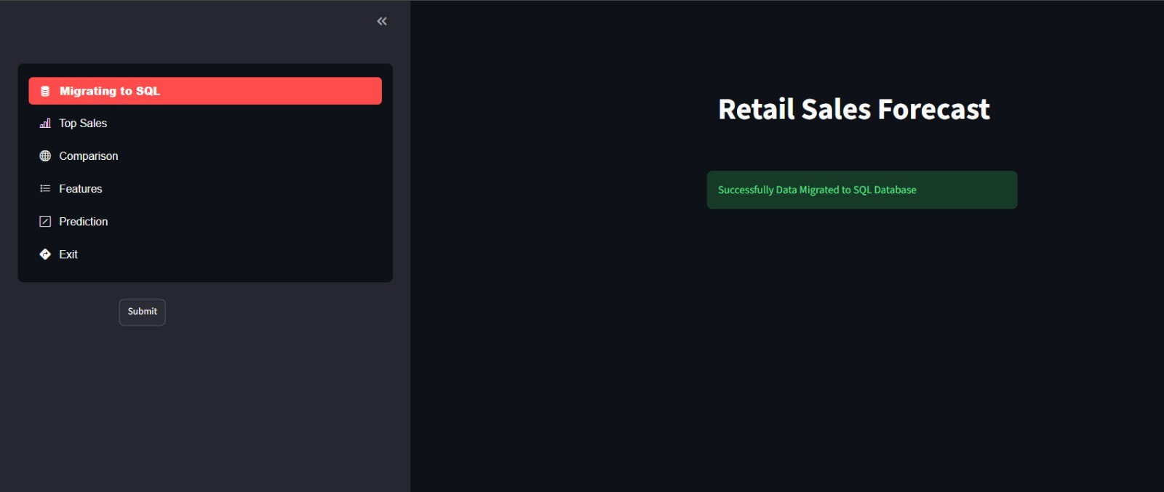

Figure 5.1 Data Migration

- Top Sales Analysis

  - Users can identify:

  - Top-performing stores

  - Top-performing departments

  - Weekly sales rankings

  - Store-wise business performance
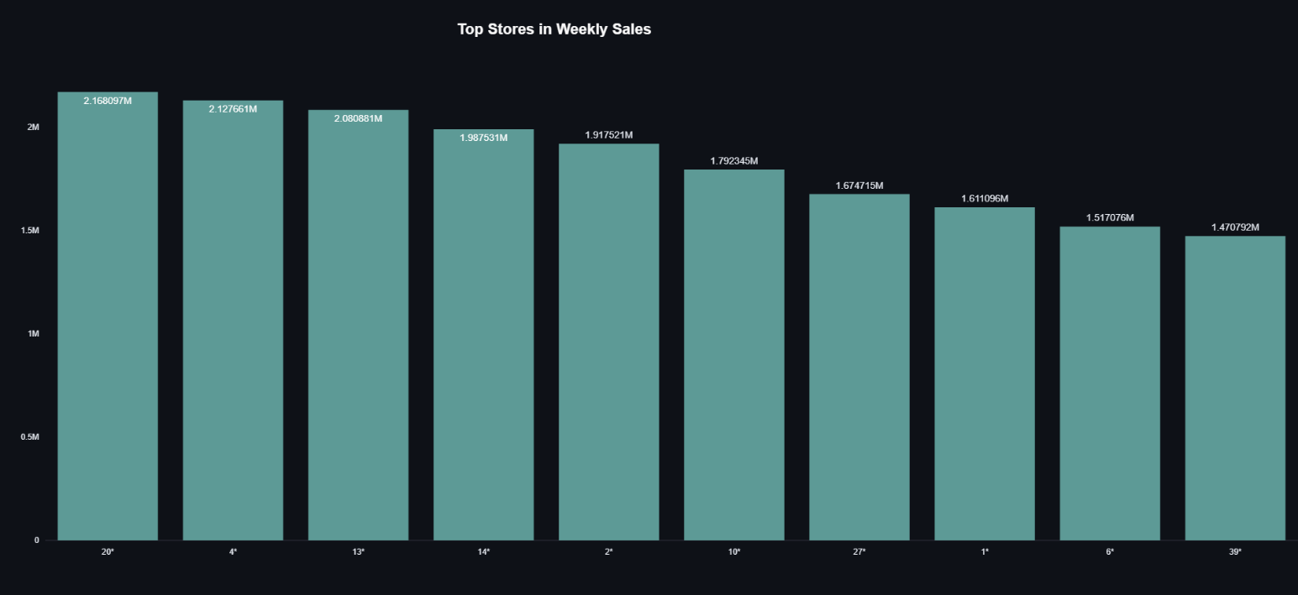

Figure 5.2 Weekly sales rankings Store wise

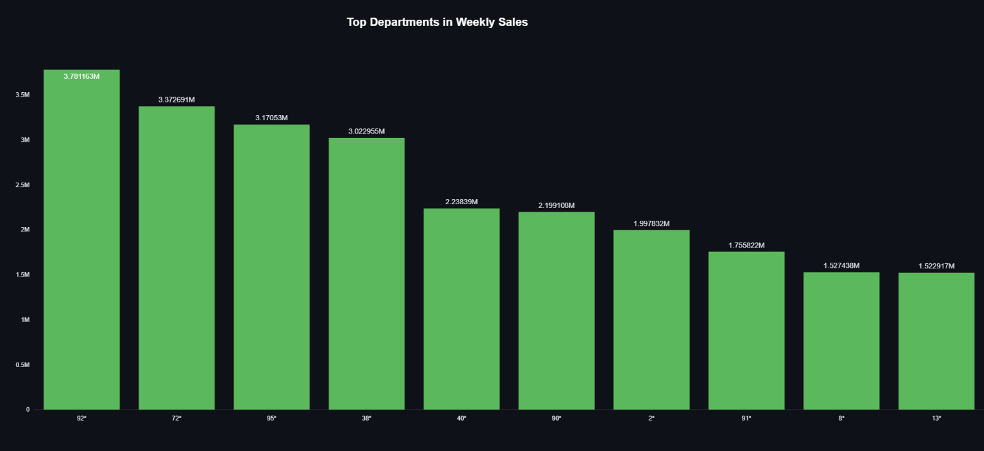

Figure 5.3 Weekly sales rankings Departments wise

Sales Comparison

  - The comparison module enables users to compare:

  - Current week versus previous week

  - Store versus store

  - Department versus department

  - Selected store against top-performing stores
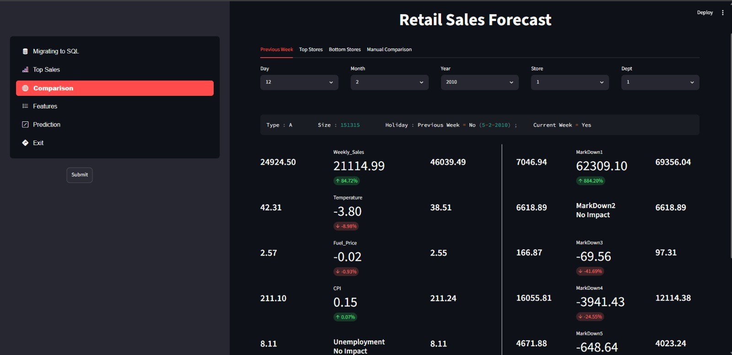

Figure 5.4 Sales Comparison Current week versus previous week

Feature Analysis

  - Interactive visualizations illustrate the impact of various business factors such as:

  - Temperature

  - Fuel Price

  - CPI

  - Unemployment

  - Promotional variables

  - Holiday effects

  - Size
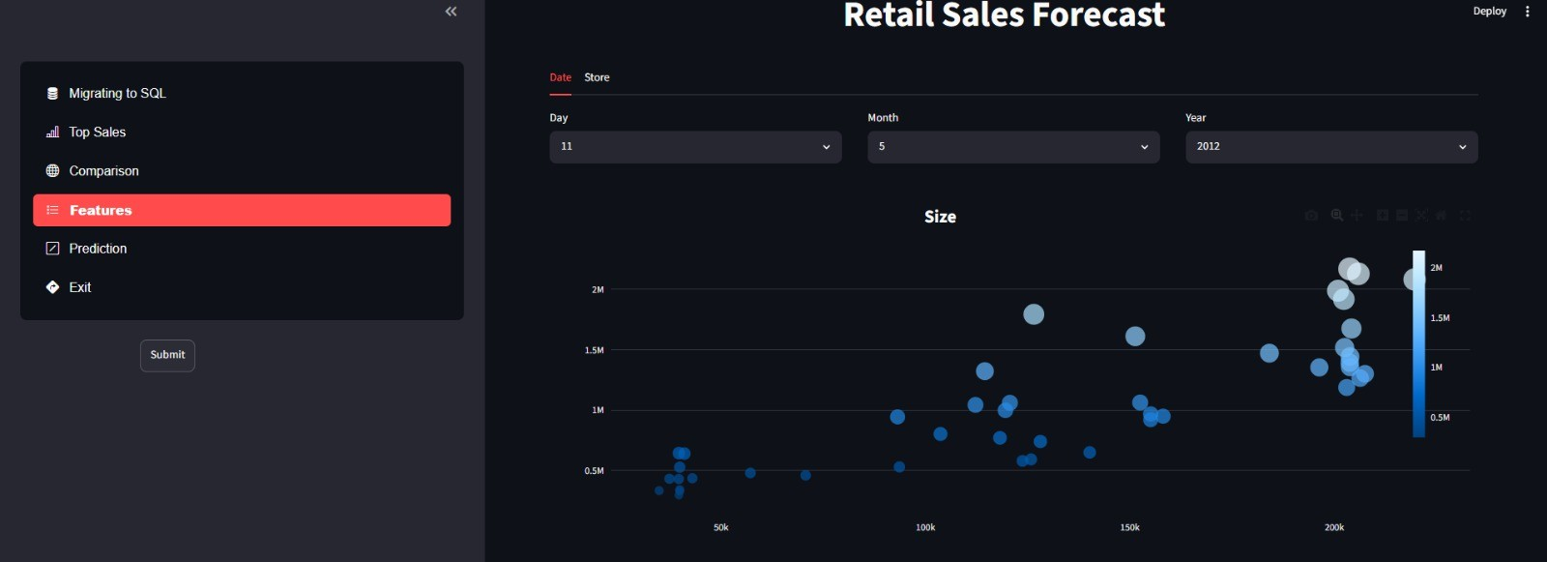

Figure 5.5 Feature Analysis on the Basis of Size

Weekly Sales Prediction

  - The prediction module accepts user input through an intuitive graphical interface and displays forecasted weekly sales generated by the trained Random Forest model.

  - Overall, the dashboard successfully integrates business intelligence, SQL reporting, and machine learning forecasting into a unified decision-support platform suitable for both technical and non-technical users.

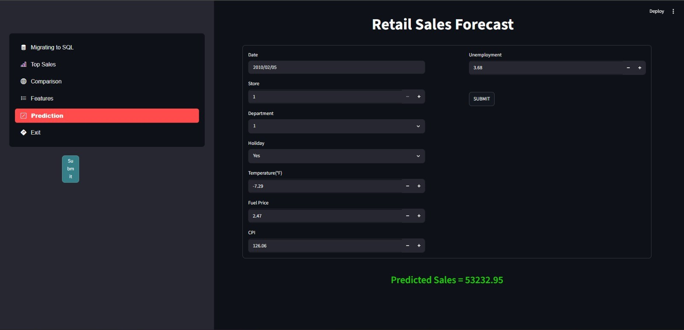

Figure 5.5 Weekly Sales Prediction

Comparative Analysis

    - To assess the effectiveness of the proposed system, comparisons were performed at both the business and machine learning levels.

    - From a business perspective, the dashboard allows users to compare stores, departments, and weekly sales across different dates. SQL-based analytical queries enable rapid retrieval of historical sales information, while interactive charts facilitate intuitive comparison of business performance.

    - From a machine learning perspective, multiple regression algorithms were evaluated before selecting the final forecasting model. The Random Forest Regressor demonstrated superior predictive capability due to its ensemble learning strategy, robustness against overfitting, and ability to model complex nonlinear relationships among retail variables.

Table 5.3 Comparison of Regression Algorithms

Regression Algorithm | Advantages | Limitations
Decision Tree Regressor | Simple to understand, easy to interpret, and requires minimal data preprocessing. | Prone to overfitting, especially on complex datasets.
Extra Trees Regressor | Faster training, improved randomness, and reduced variance compared to a single decision tree. | Slightly less interpretable due to the use of multiple randomized trees.
AdaBoost Regressor | Improves prediction accuracy by combining multiple weak learners into a strong model. | Sensitive to noisy data and outliers, which may reduce performance.
Gradient Boosting Regressor | Provides high prediction accuracy by sequentially correcting previous errors. | Requires longer training time and careful parameter tuning.
XGBoost Regressor | Delivers excellent performance on complex datasets with efficient handling of missing values and regularization. | Computationally intensive and requires hyperparameter optimization.
Random Forest Regressor | High predictive accuracy, robust against overfitting, and capable of handling large feature sets effectively. | Produces larger model sizes and requires more memory than simpler algorithms.

The comparative evaluation demonstrates that integrating comprehensive data preprocessing, feature engineering, interactive visualization, SQL-based analytics, and Random Forest–based forecasting results in a scalable and effective retail analytics platform. The system not only predicts future sales with reliable accuracy but also provides actionable business insights through interactive dashboards, making it a practical decision-support tool for modern retail organizations.

CONCLUSION AND FUTURE SCOPE

Conclusion

The Retail Sales Analysis and Forecast using Machine Learning project successfully demonstrates the practical application of data science, machine learning, and business intelligence techniques in solving real-world retail analytics problems. The developed system provides an integrated platform capable of transforming raw retail transaction data into meaningful business insights through automated preprocessing, exploratory data analysis, predictive modeling, interactive visualization, and database-driven reporting.

The project begins by integrating multiple retail datasets containing sales transactions, store information, and external business factors. Comprehensive preprocessing techniques such as dataset merging, data cleaning, feature engineering, categorical encoding, and missing value handling ensure the quality and consistency of the training data. The engineered features effectively capture temporal, environmental, and economic factors that influence weekly retail sales, thereby improving the predictive capability of the forecasting model.

Multiple machine learning regression algorithms were evaluated during experimentation to identify the most suitable forecasting technique. Based on comparative performance analysis using standard evaluation metrics, the Random Forest Regressor was selected as the final prediction model because of its superior accuracy, robustness, and ability to model complex nonlinear relationships among retail variables. The trained model was serialized and integrated into the application, allowing users to generate predictions efficiently without repeated model training.

An important contribution of this project is the development of a comprehensive Streamlit-based dashboard that combines database management, business analytics, visualization, and forecasting within a single user-friendly interface. Users can migrate datasets into a PostgreSQL database, analyze top-performing stores and departments, compare historical sales performance, explore feature impacts through interactive charts, and predict future weekly sales using the trained machine learning model. This integration significantly improves usability while supporting informed business decision-making.

Overall, the proposed system provides a scalable and modular retail analytics platform that effectively bridges the gap between traditional sales reporting and intelligent predictive analytics. Beyond forecasting, the application enables retailers to understand historical business trends, evaluate key performance indicators, and make proactive decisions regarding inventory management, sales planning, and operational efficiency. The project demonstrates that the combination of machine learning, data visualization, and business intelligence can substantially improve retail decision-support systems while providing a strong foundation for future research and industrial applications.

Limitations

Although the proposed system performs efficiently for retail sales analysis and forecasting, several limitations remain that may influence prediction performance under certain conditions.

Dependence on Historical Data

The forecasting model relies entirely on historical sales records. If the historical data contains significant inconsistencies or does not accurately represent future market conditions, prediction accuracy may decrease.

Limited External Variables

The current implementation considers several business and economic variables such as temperature, fuel price, CPI, and unemployment. However, additional factors including competitor pricing, promotional campaigns, customer demographics, inflation, and economic policy changes are not incorporated into the forecasting process.

Weekly Sales Forecasting

The system focuses primarily on predicting weekly sales. Daily, monthly, quarterly, and long-term forecasting capabilities are not fully implemented within the current version.

Static Machine Learning Model

The forecasting model is trained offline and stored as a serialized Pickle file. Consequently, newly generated sales data are not automatically incorporated into the prediction model unless manual retraining is performed.

Single Forecasting Algorithm

Although several regression algorithms were experimentally evaluated, the deployed application utilizes only the Random Forest Regressor. Ensemble forecasting or hybrid models may further improve prediction accuracy for highly dynamic retail environments.

Local Deployment

The current application is designed for local execution using Streamlit and PostgreSQL. It does not yet support distributed cloud deployment, multi-user access, or enterprise-scale retail environments.

Future Enhancements

The modular architecture of the proposed system provides numerous opportunities for future expansion and technological improvements.

Deep Learning-Based Forecasting

Future versions can incorporate advanced deep learning algorithms such as Long Short-Term Memory (LSTM), Gated Recurrent Units (GRU), and Transformer-based time-series models to improve long-term forecasting performance.

Advanced Time-Series Models

Modern forecasting frameworks such as Facebook Prophet, Temporal Fusion Transformer, AutoTS, and NeuralProphet can be integrated for handling complex seasonal and trend-based retail data.

Real-Time Data Processing

Future implementations may support streaming retail transactions using technologies such as Apache Kafka or Apache Spark, enabling real-time sales forecasting and continuous business monitoring.

Automated Model Retraining

The application can be extended to automatically retrain forecasting models whenever new sales data become available, thereby maintaining prediction accuracy without manual intervention.

Cloud Deployment

Deployment on cloud platforms such as Microsoft Azure, Amazon Web Services (AWS), or Google Cloud Platform (GCP) would enable scalable access, centralized data management, and improved availability.

Inventory Optimization

Future research may integrate inventory optimization algorithms that automatically recommend procurement quantities based on forecasted demand.

Customer Analytics

Additional modules can perform customer segmentation usingclustering algorithms and provide personalized recommendation systems through collaborative filtering and content-based recommendation techniques.

Business Intelligence Integration

Interactive KPI dashboards, executive reports, PDF report generation, email notifications, and automated decision-support systems can further enhance managerial decision-making.

Mobile and Web API Support

Developing REST APIs and mobile applications would allow external business systems and mobile users to access forecasting services remotely.

Multi-Store Enterprise Forecasting

Future versions may simultaneously forecast sales across multiple retail branches and support centralized enterprise-level analytics.

REFERENCES

- T. Hastie, R. Tibshirani, and J. Friedman, The Elements of Statistical Learning, 2nd ed. New York, NY, USA: Springer, 2009.
- G. James, D. Witten, T. Hastie, and R. Tibshirani, An Introduction to Statistical Learning, 2nd ed. Cham, Switzerland: Springer, 2021.
- L. Breiman, "Random Forests," Machine Learning, vol. 45, no. 1, pp. 5–32, 2001.

- F. Pedregosa et al., "Scikit-learn: Machine Learning in Python," Journal of Machine Learning Research, vol. 12, pp. 2825–2830, 2011.
- W. McKinney, Python for Data Analysis, 3rd ed. Sebastopol, CA, USA: O'Reilly Media, 2022.
- J. VanderPlas, Python Data Science Handbook, Sebastopol, CA, USA: O'Reilly Media, 2016.
- H. Wickham and G. Grolemund, R for Data Science. Sebastopol, CA, USA: O'Reilly Media, 2017.
- T. Chen and C. Guestrin, "XGBoost: A Scalable Tree Boosting System," in Proc. 22nd ACM SIGKDD International Conference on Knowledge Discovery and Data Mining, San Francisco, CA, USA, 2016, pp. 785–794.
- P. Harrington, Machine Learning in Action. Shelter Island, NY, USA: Manning Publications, 2012.
- C. Bishop, Pattern Recognition and Machine Learning. New York, NY, USA: Springer, 2006.
- S. Raschka and V. Mirjalili, Python Machine Learning, 3rd ed. Birmingham, U.K.: Packt Publishing, 2019.

- M. Grus, Data Science from Scratch, 2nd ed. Sebastopol, CA, USA: O'Reilly Media, 2019.
- A. Géron, Hands-On Machine Learning with Scikit-Learn, Keras & TensorFlow, 3rd ed. Sebastopol, CA, USA: O'Reilly Media, 2022.
- T. M. Mitchell, Machine Learning. New York, NY, USA: McGraw-Hill, 1997.

- Python Software Foundation, "Python Programming Language," Available: https:// www.python.org/.
- Streamlit Inc., "Streamlit Documentation," Available: https://streamlit.io/.

- PostgreSQL Global Development Group, "PostgreSQL Documentation," Available: https://www.postgresql.org/.
- Plotly Technologies Inc., "Plotly Python Graphing Library," Available: https:// plotly.com/python/.

